# Introducing React JS to Create Web Apps

Create new folder (for project folder) in your preferred location.  
Hold Shift + Right click inside created folder. And select Open PowerShell window here  
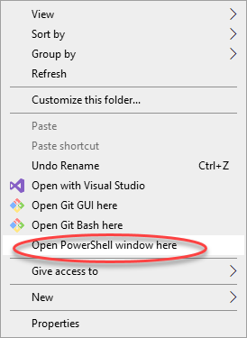

Type this command to create template code:  
**npm create vite@latest**  
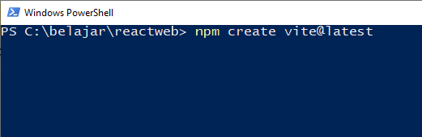

Type project/folder name:  
**project1**

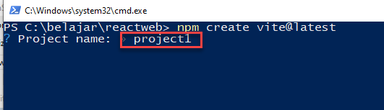

Select **React**

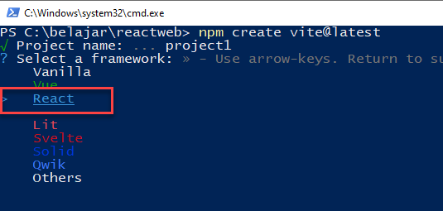

Select **Javascipt**

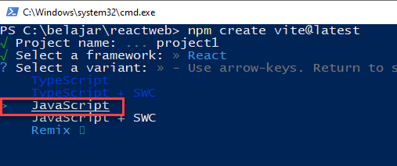

Result

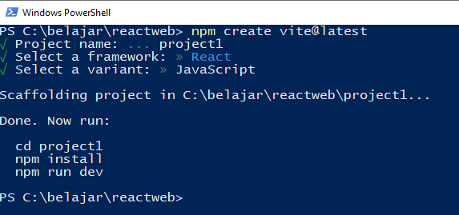

Open project folder with VS Code, open terminal  
Run:   
**npm install**  
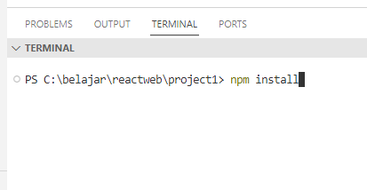

Press **CTRL + Click** on http://localhost:xxxx

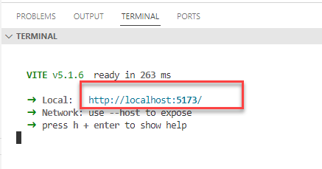

You will see this html page  
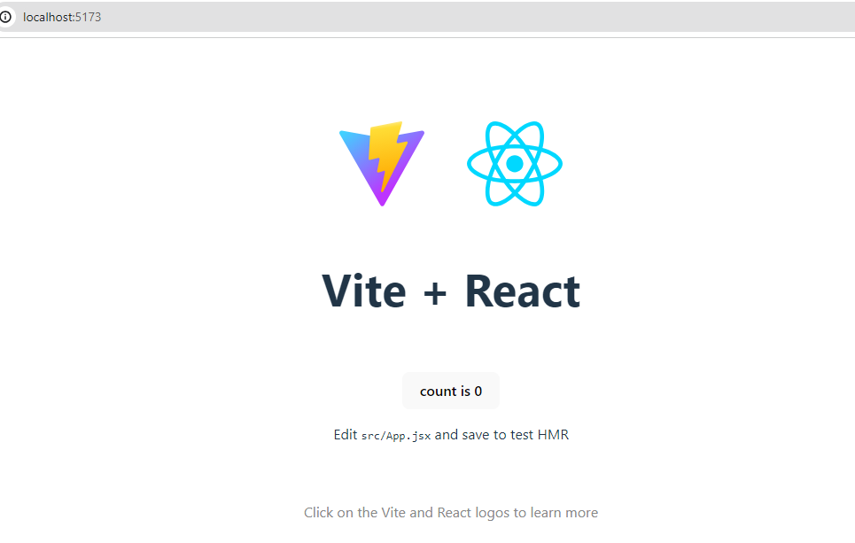

Source Code routing file structure   
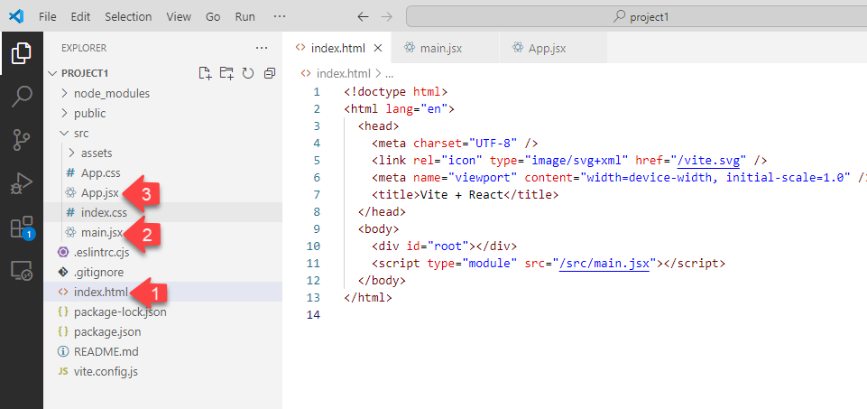

**Index.html**  
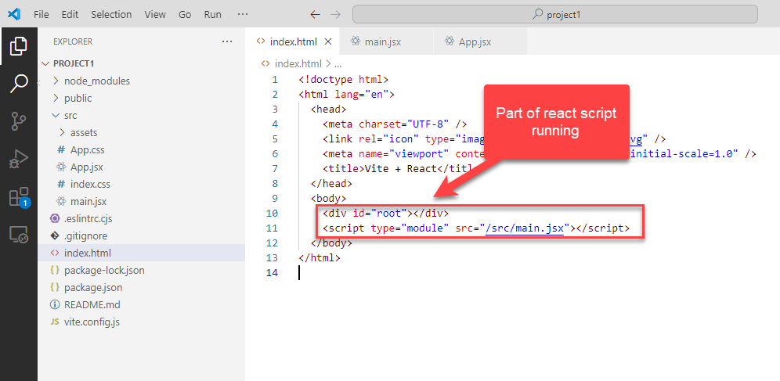

**Main.jsx**

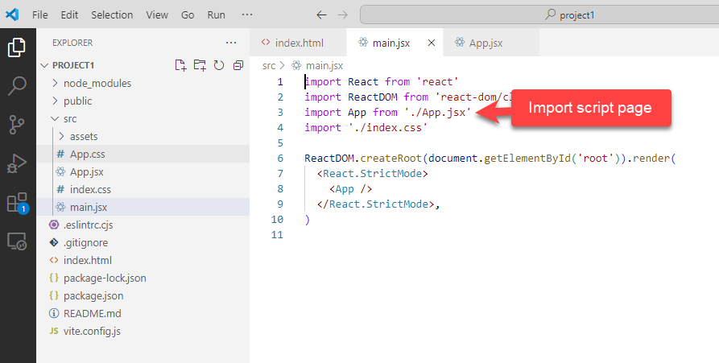

**App.jsx** (showing page)

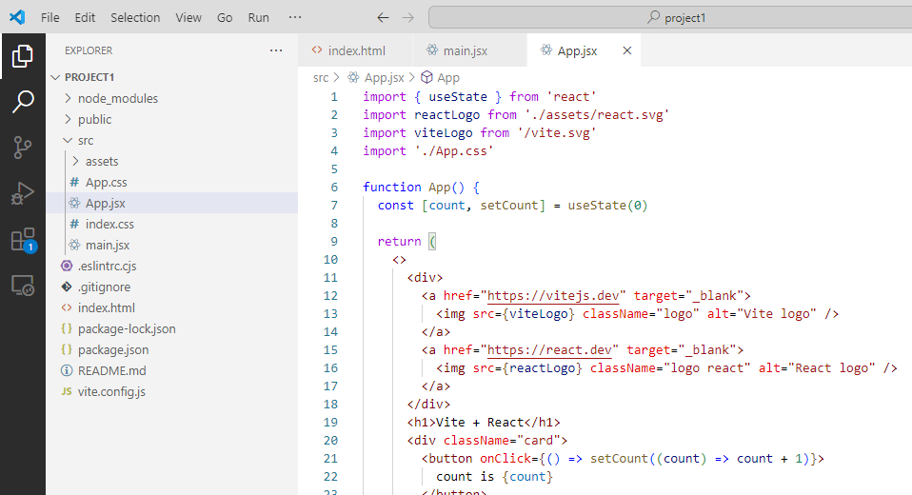

Web Apps using HTML to render page.

You can learn about HTML code here:  
<https://www.w3schools.com/html/default.asp>